Poster/Oral Presentation
Date of presentation
Time of presentation

Instruction on preparing an abstract for the
15th ISSRNS conference
X.Y. Presenting Author¹*, Z.V. Author¹, C.T. Author^{1;2} and H. Author²
¹Lord Howe Island University, Lagoon Road 1, Lord Howe Island NSW 2898, Australia
²European Synchrotron Radiation Facility, B.P.220, F-38043 Grenoble Cedex, France
*e-mail: presenting_author@det.nsw.edu.au

The preferred length of the abstract is one page. Preferred font type is Cambria¹. Size of the font used in the abstract text is 11 pt, whereas the font size in figures, legends and acknowledgements is 9 pt.
Due to the small format size, please do not put in a regular abstract more than two figures (see Fig. 1)². For best results, submit artworks in the actual size at which they should appear in the Book of Abstracts. If the figure is present, for editing purposes, please upload additional file containing the graphic file(s) of abstract figures in some popular format (i.e. jpg, bmp) with resolution 300 dpi for colour and 600 dpi for grayscale mode and with clear directions on how to put them in the text³.
Use of this template will benefit the author in that the entire abstract (text and artworks) may be submitted in one file and expedite publication, allow authors to indicate preferences for placement of artwork, and enable authors to determine whether their text is within the page limitation.
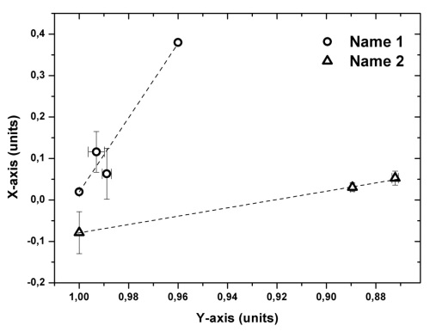
The 15th International School and Symposium on Synchrotron Radiation in Natural Science (ISSRNS’2022) will be held in Przegorzały (near Krakow), Poland, 22-25 August 2022. The programme of the Symposium will comprise invited lectures (40 minutes), oral communications (20 minutes) and poster presentations.
The official language of the meeting is English. The abstracts should be uploaded in the ABSTRACTS section of the conference site.
Figure 1. Figure name

Acknowledgements: This project was financed by …
References
1. M. Svandrlik, F. Parmigiani, Nat. Photonics 8 (2014) 82.
2. S. V. Krivovichev, Angew. Chem. 53 (2014) 654.
3. P. Murck, New age of synchrotron studies (Sun Editors, Honolulu 1891)

